# Intro to Window and Document objects

Let’s first take a look at how Window and Document are represented. The Window is part of the Browser Object Model (BOM) which is a superset of the Document object model(DOM) that contains the Document object and renders the contents.

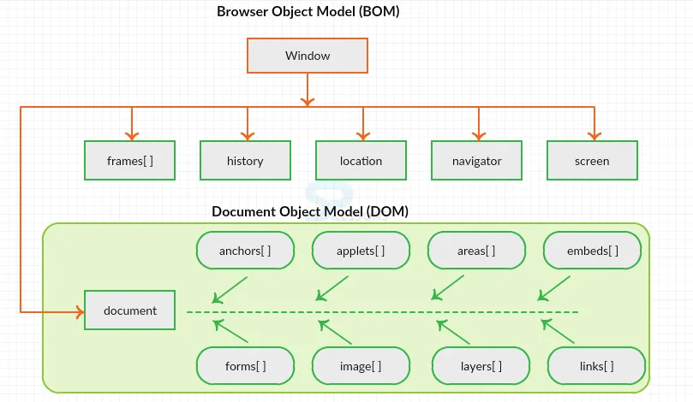

## Browser Object Model

When the browser is launched or a new tab is opened, the first to be loaded is the window and its properties which are stored in the window object. Every tab in the browser will have its own window object meaning they can have their own set of attributes.However, some web browsers can allow overall window size or layout of the other tabs to be modified.

The **window** object may be accessed by ***window.propertyname***

## Document Object Model

The Document Object Model (DOM) is created when the window object has been loaded and it renders the contents of the HTML document. The DOM represents the HTML content as a tree structure with the document object as the root element.

The **document** object may be accessed by ***document.propertyname***

It can also be accessed by ***window.document.propertyname***since the document object is a child of the window object thus the window object has a reference to it.

Now, to compare the differences between Document and Window object

| Document | Window |
| --- | --- |
| It is a part of Document Object Model (DOM) which is a subset of BOM | It is a part of Window Object Model (BOM) |
| It represents the HTML document or web page that can be interfaced by the DOM | It represents a window and it can render a document using the DOM |
| It is loaded within the window, as it is a part of the DOM | The first object to be loaded by the browser, which then invokes the loading of the document object and its rendering via DOM |
| It is the root element of the DOM | It is the global element for all objects, functions and other features and it is the root element of BOM |
| Not able to access window objects properties inside the document | Able to access document properties indirectly |
| The methods can share same name as window object but behavior can vary | The methods can share same name as document object but behavior can vary |

References: <https://sushmithavootukuri.medium.com/difference-between-window-document-and-screen-in-javascript-757a65b25e9a>

<https://www.geeksforgeeks.org/how-are-the-javascript-window-and-javascript-document-different-from-one-another/>